TEACHER NOTES FOR EXPLORING KINETICS

Introduction
Kinetics is the study of motion of the particles along with their cause (ex. forces and torques). It asks “why did the velocity change?”
- Learning about pendulum’s experiment: https://explorable.com/pendulum-experiment
- Pendulum simulation: https://phet.colorado.edu/en/contributions/view/3484?
- Forces and motion simulation: https://phet.colorado.edu/en/simulation/forces-and-motion-basics
- Friction simulation: https://phet.colorado.edu/sims/html/friction/latest/friction_en.html
- Pendulum collision experiment involving force, energy, friction, momentum

Relevant 2016 ICP Content Standards
Standard 2: Uniform Acceleration
Standard 3: Newton’s Laws of Motion (One Dimension)
Standard 4: Energy

Relevant Physics 1 Standards
Standard 2: Constant Acceleration
Standard 3: Forces
Standard 4: Energy
Standard 5: Linear Momentum In One Dimension
Standard 6: Simple Harmonic Oscillating Systems

Included Materials
- 12 wooden blocks weighing 200 g
- 12 wooden blocks weighing 100 g with screw eye and string
- 12 pieces of plywood
- 12 rulers
- 12 protractors
- String

Calculations

Given

$m_{1}=100g=0.1 kg$
$m_{2}=200 g=0.2 kg$
$μ_{k}=0.5$
$h=10 cm=0.1 m$
${v_{1}}_{top}=0 m/s$
${v_{2}}_{before collision}=0 m/s$
${v_{1}}_{after collision}=0 m/s (assume m_{1} stops after collision)$
No mass change during collision

Problem

${v_{1}}_{bot}={v_{1}}_{before collision}= ?$
${v_{2}}_{after collision}= ?$
${a_{2}}_{after collision due to friction}= ?$
$d= ?$

Solution

(1) Energy
$E_{top}=E_{bot}$
$PE_{top}=KE_{bot}$
$m_{1}gh_{top}=\frac{1}{2}m_{1}{{v_{1}}_{bot}}^{2}$
$\boxed{{v_{1}}_{bot}=\sqrt{2gh_{top}}}$
${v_{1}}_{bot}=\sqrt{2(9.8m/s^{2})(0.1 m)}=\sqrt{1.96\frac{m^{2}}{s^{2}}}=\boxed{1.4 m/s}$

(2) Momentum
$\sum{p_{before collision}}=\sum{p_{after collision}}$
$m_{1}v_{1 before}+m_{2}v_{2 before}=m_{1}v_{1 after}+m_{2}v_{2 after}$
$m_{1}v_{1 before}+0 kgm/s=0 kgm/s+m_{2}v_{2 after}$
$\boxed{v_{2 after}=\frac{m_{1}v_{1 before}}{m_{2}}}$
$v_{2 after}=\frac{(0.1 kg)(1.4 m/s)}{(0.2 kg)}=(\frac{1}{2})(1.4 m/s)=\boxed{0.7 m/s}$

(3) Force
$F_{net}=m_{2}a_{2}=-F_{f_{k}}$
$m_{2}a_{2}=-μ_{k}F_{n} since F_{f_{k}}=μ_{k}F_{n}$
$m_{2}a_{2}=-μ_{k}m_{2}g since F_{n}=m_{2}g in this case$
$\boxed{a_{2}=-μ_{k}g}$
$a_{2}=-μ_{k}g=-\left(0.5\right)\left(9.8 m/s^{2}\right)=\boxed{-4.9 m/s^{2}}$

(4) Kinematics
$v_{f}^{2}=v_{i}^{2}+2ad$
$\boxed{d=\frac{v_{f}^{2}-v_{i}^{2}}{2a}}$
$d=\frac{v_{f}^{2}-v_{i}^{2}}{2a}=\frac{{\left(0 m/s\right)}^{2}-{\left(0.7 m/s\right)}^{2}}{2(-4.9 m/s^{2})}=\frac{0.49}{9.8} m=\frac{1}{20}m=\boxed{0.05 m=5 cm}$

(5) Work
Deriving and equation for d based on m₁, m₂, h, and $μ_{k}$
Work is done by the non-conservative force of friction
$W=F_{f_{k}}d\cos{θ_{between}}$
$W= F_{f_{k}}d\cos\left(180°\right)$
$W=-F_{f_{k}}d since \cos\left(180°\right)=-1$
$W=-μ_{k}F_{n}d since F_{f_{k}}=μ_{k}F_{n}$
$W=-μ_{k}m_{2}gd since F_{n}=m_{2}g in this case$
$-{KE}_{after collision}=-μ_{k}m_{2}gd since W=∆KE=0 J-{KE}_{after collision}=-{KE}_{after collision}$
Note: KE may be lost during the collision (inelastic) so we use the KE after the collision for Work
$\frac{1}{2}m_{2}{v_{2 after}}^{2}=μ_{k}m_{2}gd$
$\frac{1}{2}{v_{2 after}}^{2}=μ_{k}gd since m_{2} is on both sides$
$\frac{1}{2}{\left(\frac{m_{1}v_{1 before}}{m_{2}}\right)}^{2} =μ_{k}gd since v_{2 after}=\frac{m_{1}v_{1 before}}{m_{2}}$
$\frac{1}{2}{\left(\frac{m_{1}\sqrt{2gh_{top}}}{m_{2}}\right)}^{2} =μ_{k}gd since {v_{1}}_{bot}=\sqrt{2gh_{top}} and {v_{1}}_{bot}={v_{1}}_{before collision}$
$\frac{1}{2}{\left(\frac{m_{1}}{m_{2}}\right)}^{2}{\left(\sqrt{2gh_{top}}\right)}^{2} =μ_{k}gd$
$\frac{1}{2}{\left(\frac{m_{1}}{m_{2}}\right)}^{2}2gh_{top} =μ_{k}gd$
${\left(\frac{m_{1}}{m_{2}}\right)}^{2}h_{top} =μ_{k}d since g is on both sides and \frac{1}{2}*2=1$
$\boxed{d={\left(\frac{m_{1}}{m_{2}}\right)}^{2}\frac{h_{top}}{μ_{k}}}$
$d={\left(\frac{m_{1}}{m_{2}}\right)}^{2}\frac{h_{top}}{μ_{k}}={\left(\frac{0.1 kg}{0.2 kg}\right)}^{2}\frac{0.1 m}{0.5}={\left(\frac{1}{2}\right)}^{2}\left(\frac{1}{5}\right)m=\frac{1}{20} m=\boxed{0.05 m=5 cm}$

(6) Graph of d vs. h
$d={\left(\frac{m_{1}}{m_{2}}\right)}^{2}\frac{h_{top}}{μ_{k}}$
$d=\left[{\left(\frac{m_{1}}{m_{2}}\right)}^{2}\frac{1}{μ_{k}}\right] h_{top} + 0$
y = m x + b
$\boxed{Slope={\left(\frac{m_{1}}{m_{2}}\right)}^{2}\frac{1}{μ_{k}}}$
${\left(\frac{0.1}{0.2}\right)}^{2}={\left(\frac{m_{1}}{m_{2}}\right)}^{2}\frac{1}{μ_{k}}={\left(\frac{0.1 kg}{0.2 kg}\right)}^{2} \frac{1}{0.5}=\left(\frac{1}{4}\right)\frac{2}{1}=\frac{2}{4}=\frac{1}{2}=\boxed{0.5}$
If $m_{1}>m_{2}$, then the slope increased (block 2 goes farther since d increases)
If $μ_{k}$ goes down, then the slope is increased (block 2 goes farther since d increases)
Note: From trig, height h can be related to angle $θ$ and length L $\boxed{h=L-L\cos{θ}}$

$\%_{error}=\left|\frac{\#_{theoretical}-\#_{experimental}}{\#_{theoretical}}\right|×100\%$

$\%_{error}=\left|\frac{0.5 - 0.4533}{0.5}\right|×100\%=\boxed{9.34\%}$

EXPERIMENT: EXPLORING KINETICS

Introduction
In this lab, you will analyze the energy of a pendulum collision. Recall the following:
- Force is any interaction that, when unopposed, will change the motion of an object.
$\boxed{F=ma}$ $\boxed{{F_{f}}_{k}=μ_{k}F_{n}}$ $\boxed{F_{g}=mg}$
- Momentum refers to the quantity of motion that an object has as a product of mass and velocity.
$$\boxed{p=mv}$$
- Energy is the ability to do work or to cause change. It is a property which can be transferred or converted into different forms commonly measured in the SI unit Joules (J)
- Mechanical Energy $(E_{mec.})$ is the sum of an object’s potential energy and kinetic energy. It is associated with the motion and position of everyday objects.
$$\boxed{Mechanical Energy \left(E_{mec.}\right)=PE+KE}$$
- Potential Energy is energy that is stored as a result of position or state. Gravitational Potential Energy depends upon an object’s mass m, height h, and gravity g. This type of potential energy increases when an object is raised to a higher level.
$$\boxed{Gravitational Potential Energy \left({PE}_{grav.}\right)=mgh}$$
- Kinetic Energy is energy of motion such as an object with mass m moving at velocity v.
$\boxed{Kinetic Energy \left(KE\right)=\frac{1}{2}mv^{2}}$
- Work is a mechanism of energy transfer.
$$\boxed{W=Fd \cos{θ_{between}}}$$

Hypothesis
How far will a 200g block travel with a coefficient of kinetic friction of 0.5 after being hit by a 100g block on a pendulum dropped from a height of 10 cm? How will the height h affect the distance d?

Experiment Design
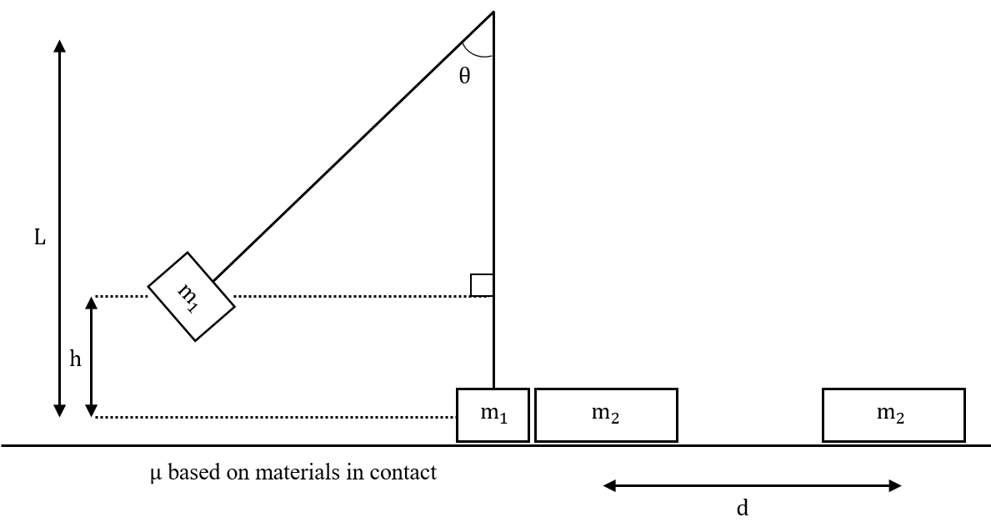
Materials

- 1-m string
- Piece of plywood
- 100 g block with metal screw eye
- 200 g block
- Ruler
- Tape or ring stand

Procedure
- Make a pendulum by tying the piece of string to the metal screw eye. Hang the pendulum over the edge of a desk or on a ring stand so that the block just clears the top of the plywood placed on a level surface beneath it. Tape the upper end of the string if needed.
- Place the 200g block on the plywood so that it will collide with the 100 g block when the pendulum string is vertical. Let the 100 g block hang in place next to the 200 g block to make sure the collision will happen properly.
- Pull the bob up and to the side until it increases its height by 5 cm, 10 cm, 15 cm, and 20 cm. Release the block for each height three times and take the average. Record the data in the table below. You can discard a trial if you have a good reason to do so (ex. block hits plywood instead of other block).

Data

Height of 100g Wood Block (cm) | Distance 200g Wood Block Moved (cm)
 | Trial #1 | Trial #2 | Trial #3 | Average
0
5
10
15
20
Analysis

- Graph your distance vs. height (you can use graphing software like excel or sheets as well)

Dependent variable vs. Independent variable (by convention)

Responding (Dependent) variable

Manipulated (Independent) variable

- Based on your data, how did the impact height affect the distance?

- What are some sources of error?

Conclusion

- Was your hypothesis correct? Explain.

- When does a swinging pendulum have the most kinetic energy?

- Where did the pendulum get its kinetic energy?

- Was there energy lost in the collision? What can we assume was conserved?

- Why did the 200 g wooden block stop?

